HEY ADAM. DO YOU BELIEVE IN CRAZY?
By Adam I Stratmeyer,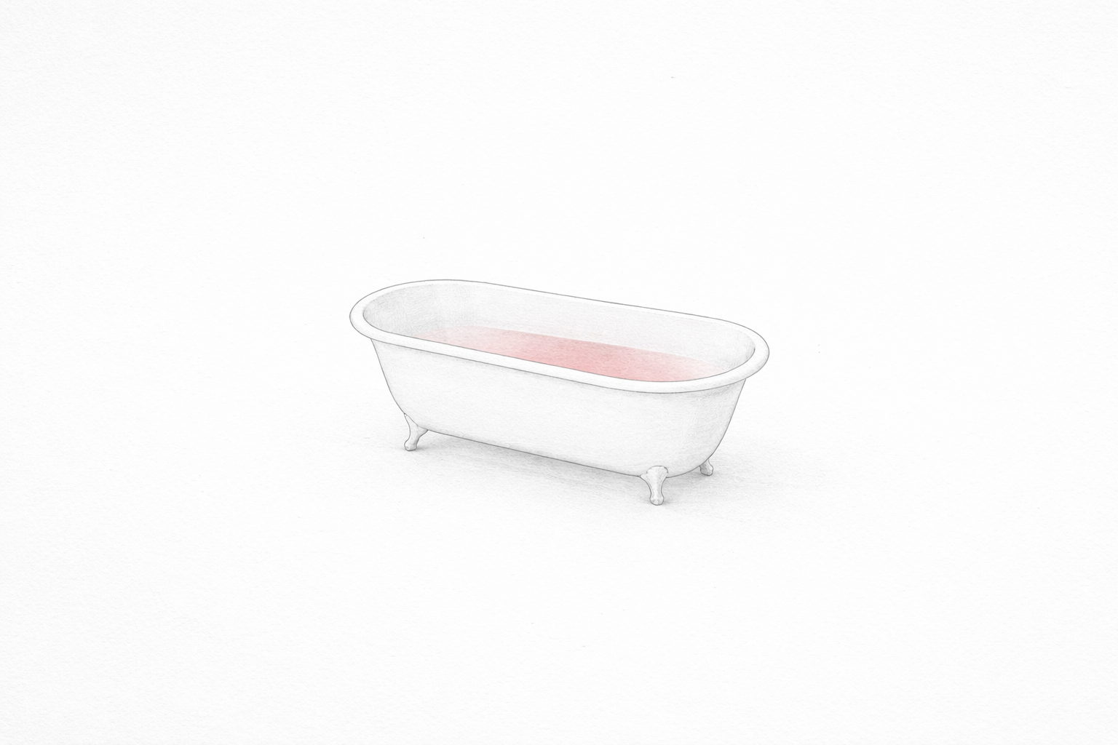
People ask me on occasion, if I believe in crazy. It’s a rigged question, they aren’t looking for a clinical definition, they’re looking for a border wall. They want me to draw a line in the dirt between "normal" people and the wreckage, so they can feel safe in their own boring-ass heads.

I have countless, countless examples of lived crazy, like a lot of people do but just don't talk about.

At one party, I watched a guy get beat with a heavy-ass frying pan while he was cooking onions. My other Friend doing the beating threw the searing onions into the guy's eyes, and then hammered his head with the iron until the aluminum pan [cheap chinesium shit] folded in half like tin foil. My friend didn’t even stop talking. He took the impacts like a mule, head ringing, still upright, still moving the fuck on.

At that same party, I walked past a bathroom once where two women sat in the tub together eating glass shards. Blood on white porcelain, crunching like hard candy, while downstairs others shot up Robitussin. I’ve seen crazy try to out-crazy crazy, usually in the context of female engagements, ironically. Bitch be crazy. It’s pure primate dominance display dialed to eleven, a survival bluff where you signal you’re the one willing to go furthest into the abyss. You escalate until the other person backs down.
Much of what gets tagged "crazy" is just performance, leaning into the role because the environment rewards the most unhinged display. Is that the crazy you’re looking for? To me, it just looks like humans operating at an intensity a supposed reasonable, prudent person can't stomach. It's a deviation from the norm, sure, but the norm is just a story we tell ourselves so we don’t have to look at what’s really in the bathtub.

I worked at a youth psychiatric residential treatment facility [PRTF/ARU], engaged pretty heavily on the floor. There were a lot of people that genuinely cared there, but talk about crazy. Trying to out-crazy crazy. I read the charts every shift: homicidal ideation, recurrent suicide attempts, borderline, cutters.

These were kids who’d been smoking meth since they were five years old. Their brains had been scorched by environment, threat detectors wired permanently to "on." But sit down and actually listen, an act so radical everyone else was too busy charting, and you saw they weren’t diseased. They seemed as sane as anybody else, and they fucking were. They were ordinary people reacting to abnormal amounts of evil. They weren't crazy, they just told the wrong person they were furious, and the system pounced. Diagnosis pays better than remedy.

Flip through those charts and look at the treatment: amphetamines to wake up, benzodiazepines to sleep, mood stabilizers layered on like spackle. A fucking ridiculous polypharmacy carousel. Up all day on speed analogs, crashing at night on benzos, stabilized into numbness with whatever anticonvulsant cocktail was trending. Half the mental illness was iatrogenic, manufactured by the chemical yo-yo.

Why is she sobbing at 3 a.m.? Oh right, you fucking cold-turkeyed her off the benzodiazepine she’d been dependent on for years. Great job getting her addicted first, then blaming the withdrawal for the breakdown asshole. I’ve watched girls doing their own titration, trying to figure out how much benzo they should wean themselves off of, only to be denied even that dignity. The psychopharmacology became its own etiology, feeding the charts that justified more drugs. Nervous system screaming.

Credit where it’s due, I know some damn fine psychologists who do the work okay. I’m a proponent of Cognitive Behavioral Therapy [CBT], it’s good to look at the shit you do and then evaluate it. Another ‘genius’ piece of psychology. But I have zero fucking tolerance for the medical model. It’s a bloated, self-perpetuating corpse that treats mental disorders as literal diseases when they are not the same thing.

It thickens with every edition not because humanity is deteriorating, but because irrelevant pseudoscientists need publications to keep tenure and justify salaries. When a friend finished clinical training, back when it was affordable, I’d hand them a copy of the DSM-II [1969]. I’d point to the homosexuality diagnosis and say, "This was official truth once. You were crazy if you were gay. Homosexuality is a mental disorder, huh? Now you’re wielding the “correct” current version to damage lives on evidence that’ll be The same perfect correct model. in twenty years. Maybe ease up on the certainty." I wanted to smack the smug assurance of them. Attribution theory at its most poisonous. You tell someone they're bipolar, goddamnit, they'll find a way to live it.

You have to give Freud some credit, his breakthrough was simple. He actually fucking listened. [Radical] in its time. Of course, he needed mountains of cocaine to stomach the volume of bullshit people dumped on him, and the coke sped his libido way out of control. Gee, I wonder why he came up with all that sex stuff. People always say Freud's theories were half baked and half cooked, but you know what, he was really high on coke. It makes perfect sense. It is his fault we have the medical model, but I'm not going to blame him for what modern people have done with it. To take his work and then run around acting like you're a medical doctor, with your fucking PHD, is a little bit disingenuous.

Secret nonsecret from the counseling centers: staff are usually closest to the brink. If crazy were real, they’d be first in line for the tag. They seek the friction because their own inner wiring is just as ragged.

They adore saying "holistic" like it’s armor. Then they outline their four aspects of the approach and I have to point out they’re dissecting a person into four labeled chunks. That’s segmentation, not wholeness. Vocabulary matters. If you can’t name your own sleight-of-hand, you shouldn't touch another mind.

I know what words can do. Middle school taught me, five well-aimed words could hand a girl an eating disorder. You wanna give someone an eating disorder? It ain’t hard. You find the crack, then you press. I used to watch the behavioral reorganization around a planted BS like it was field research.

I was wrong. Cruel. Projecting my own bitchass insecurities. I tracked some of them down and apologized. Not because it erases the harm, it doesn’t, but because they deserved to hear I was the weak one back then, not them. I saw vulnerability and I chose to put attention on others, and push on those special fracture lines out of insecurity, and truthfully the scientific inquiry was just a byproduct. It's probably crazy to erroneously injure other people.

Since we're here., I have to bring up the fact.We live in a country where the majority of the population genuinely believes the entire universe was magically conjured into existence by a deity who has very strong, very specific opinions about shellfish consumption and the removal of penis skin. They spend their lives bowing to this narrative, then have the audacity to look at someone else with a slightly different version of the same, magic vengeful, wrathful, all loving, all caring, jealous God story and call them dangerous. Because they don't carry the exact same delusion.

That sounds pretty durn crazy to me.

We live in a world that serves up constant, detrimental contradictions. We identify with manufactured political binaries, screaming that our side holds the truth while the other side only lies, blind to the in-group rot in our own heads. We refuse to accept the basic math, that we are all almost certainly wrong about almost everything.

So no. As it stands and as it has stood. I don’t believe in crazy.

If I did, I’d have to put everyone in that box. The religious fundamentalists, the political tribalists, the glass-eaters, and the clinical staff. We are all just deviations from a norm that never existed. We are all just trying to navigate a universe we don't understand with tools that are mostly broken. In a brief flash of existence.

The only difference between the "sane" and the "insane" is how well you can hide the bathtub full of blood. I just stopped hiding the bathtub.

Amor fati. I'm probably crazy.

